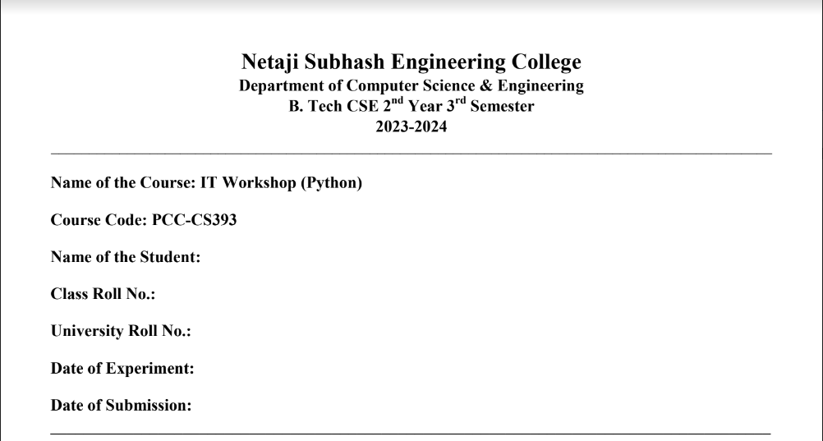
Assignment No. : 1

Problem Statement: Write a program to convert temperature from degree Celsius to degree Fahrenheit.

Python Code:

TempCelsius=int(input("Enter the temperature which you want to convert:"))
TempFahrenheit=((TempCelsius*9)/5)+32
print(TempCelsius, ”degree C =”, TempFahrenheit, “degree F”)

Sample Output:
___________________________________________________________________________________________________________
Assignment No. : 2

Problem Statement: Write a program to calculate the area and perimeter of a rectangle.

Python Code:
import math
def AreaTri(s1,s2,s3):
s=(s1+s2+s3)/2
area=math.sqrt(s*(s-s1)*(s-s2)*(s-s3))
return area
def PeriTri(s1,s2,s3):
return s1+s2+s3
s1,s2,s3=map(int,input("Enter the length of the 3 sides").split())
print("What do you want to calculate?\n1. Area \n 2. Perimeter")
ans=int(input("Enter 1 or 2"))
if ans==1:
print(AreaTri(s1,s2,s3))
else:
print(PeriTri(s1,s2,s3))

Sample Output:

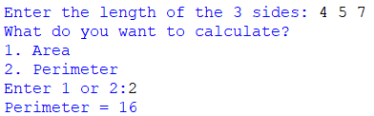
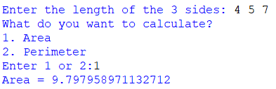
____________________________________________________________________________________________________________
Assignment No. : 3(a)
Problem Statement: Write a program to swap the value of two variables using a third variable.
Python Code:
a=int(input("Enter the first number:"))
b=int(input("Enter the second number:"))
temp=a
a=b
b=temp
print("The modified value of first number is =",a)
print("The modified value of second number is =",b)
Sample Output:
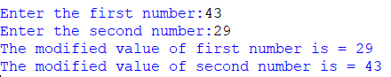
____________________________________________________________________________________________________________
Assignment No. : 3(b)
Problem Statement: Write a program to swap the value of two variables without using a third variable.
Python Code:
a=int(input("Enter the first number:"))
b=int(input("Enter the second number:"))
a,b = b,a
print("The modified value of first number is =",a)
print("The modified value of second number is =",b)
Sample Output:
_______________________________________________________________________________________________________
Assignment No. : 4

Problem Statement: Write a program to swap two numbers using bitwise operators.

Python Code:
a=int(input("Enter the first number:"))
b=int(input("Enter the second number:"))
temp=a
a=b
b=temp
print("The modified value of first number is =",a)
print("The modified value of second number is =",b)

Sample Output:
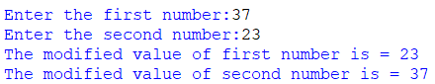

___________________________________________________________________________________________________________
Assignment No. : 5

Problem Statement: Write a program to rotate the value of x, y, and z such that x has the value of y, y has the value of z and z has the value of x.

Python Code:
x=int(input("Enter the first number:"))
y=int(input("Enter the second number:"))
z=int(input("Enter the third number:"))
x,y,z=y,z,x
print("The modified values of the given numbers are:")
print("First number =",x)
print("Second number =",y)
print("Third number =",z)

Sample Output:
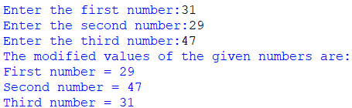

____________________________________________________________________________________________________________

Assignment No. : 6

Problem Statement: Write a program to display the following numbers: 5678, 678, 78, 8, where the given number is 5678.

Python Code:
a=int(input("Enter the number:"))
x=len(str(a))
while x>0:
print(a%(10**x))
x=x-1

Sample Output:

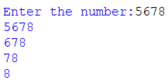
____________________________________________________________________________________________________________

Assignment No. : 7

Problem Statement: Write a program to add two complex numbers by reading the numbers from the user.

Python Code:

fr,fc=map(int,input("Enter the real and complex part of the first number: (with space)").split())
f=complex(fr,fc)
sr,sc=map(int,input("Enter the real and complex part of the second number: (with space)").split())
s=complex(sr,sc)
print(f+s)

Sample Output:

____________________________________________________________________________________________________________

Assignment No. : 8

Problem Statement: Write a program to accept the principal amount, rate of interest, and duration from the user. Calculate the interest amount and the total amount (principal + interest).

Python Code:

prin=int(input("Enter the principal amount:"))
roi=float(input("Enter the rate of interest:"))
dur=int(input("Enter the duration(in years):"))
print(prin+dur*(prin*(roi)/100))

Sample Output:




